9:27 AM
@Akshit
1. >>>>>>>>>>>>>>>>>>>>>>>>>>>>>>>>>>>>>>>>
We need relational db for point 2 after verification completion we need save everything to relational database.
For point 3 we need to create IDE like remix for interaction with contract save in relational databas
For getting the transaction details at that is possible but for daily view we need to use relational data base
We need to make an api for fetching contracts details need to save in realtional db for good interactions
"Need time 1 month for getting everthing similar to etherscan and we need relational db developer."
>>>>>>>>>>>>>>>>>>>>>>>>>>>>>>>>>>>>>>>>>
My reply : Well, as for remix. Can people even use it? Won't things like liquidity lock, verification require our launchpad?
I am not getting what you are saying exactly but in our case
- LIQUIDITY LOCK ONLY FOR IF PEPOLE USING OUR LAUNCPAD.
- WE CAN NOT RESTRICTED PEOPLE BECAUSE OF PUBLIC CHAIN
- VERIFICATION IS FOR EXPLORER

2. >>>>>>>>>>>>>>>>>>>>>>>>>>>>>>>>>>>>>>>>
Anti-snipper :::::::Its not blockchain work (we need AI or solidity scraping for this ) need some r&d
>>>>>>>>>>>>>>>>>>>>>>>>>>>>>>>>>>>>>>>>
My reply : From buying in the mempool and prevent MEV bot front running
Miners/nodes are also able to front-run as a way to increase their yields. This occurs when a miner detects a potentially profitable transaction in the mempool, e.g. a flash loan or large transaction from a well-known wallet (such as a hedge fund), and executes a similar transaction first — albeit with a higher fee. This would then be mined first, allowing them to essentially steal the victim’s alpha and gains.

In our case there are no miners only validators are their and they will get the transaction on lottery basis you can check Ethereum v2 documentation for that

3. >>>>>>>>>>>>>>>>>>>>>>>>>>>>>>>>>>>>>>>>
For renounce details more reference , sending two screenshots.

IN THESE SCREENSHOT THEY MENTION THE PROBLEM NOT ANY SOLUTION OR NOTHING LIKE WHAT THEY ARE USING FOR ACHIEVING THIS CAN YOU PLEASE SHARE THE LINK OG THIS WEBSITE SO THAT I WILL GET BETTER VIEW HOW TO ACHIEVE THIS.
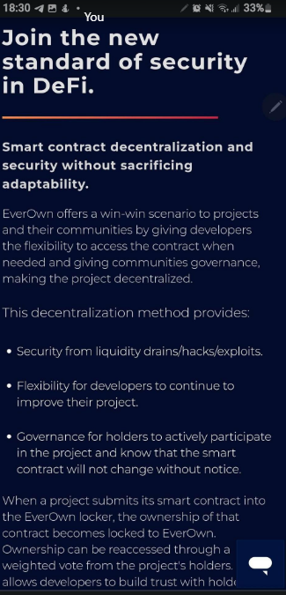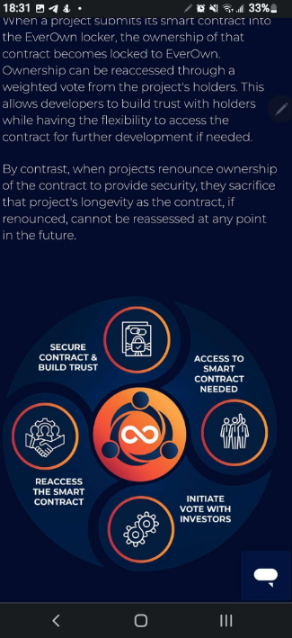

4. >>>>>>>>>>>>>>>>>>>>>>>>>>>>>>>>>>>>>>>>>>>>
For anti-snipper, i am uploading one video(pancake bot 2.mkv) for what i have. also.
Sniper bots like this video wait for dev to add liquidity or launch with a methodID. The Sniper buys exact same time copying the gas from the devs transaction. He can then buy a huge supply of the token in block0 (mempool). I don't want snipers to buy in block 0-1 after the token launches.

FOR THIS WE CAN ADD 2 FACTOR AUTHENTICATION LIKE ANY PUZZLE SOLVING OR SOMETHING BEFORE EVERY FEATURES OF OUR DEX

5. >>>>>>>>>>>>>>>>>>>>>>>>>>>>>>>>>>>>>>>>>>>
MEV/Frontrun bots
https://coinmarketcap.com/alexandria/article/frontrunners-and-mev-explained-how-to-beat-the-bots

